**Task 3 – Text Extraction from Container Image**

**Objective**

The goal of Task 3 was to extract key printed details (such as container number, capacity, and weight) from a real-world container image using Optical Character Recognition (OCR) techniques. Due to the nature of the image—containing background noise, complex textures, and varying text clarity—multiple methods were tested and evaluated.

**Methods with Resalt**

**Tesseract (Direct):**

* Weak
* Poor performance with no clear structure or usable results.

**OpenCV Contours + Tesseract:**

* Poor
* Detected irrelevant areas from the image (ground, textures) leading to many false positives.

**EasyOCR:**

* Moderate
* Detected key data such as 'BSIU 833165', 'TARE', and '4561', though with some noise and duplicate values.

**PaddleOCR:**

* Moderate
* Produced reasonable output, but results were inconsistent and contained formatting artifacts.

**Keras-OCR:**

* Moderate
* Performed similarly to EasyOCR with slightly more distortion and noise.

**Test-Time Augmentation (TTA):**

* Best
* Provided the best results by applying OCR to different visual versions of the image (contrast-enhanced, grayscale, sharpened).

**Observations and Results**

- Most OCR tools (**EasyOCR, PaddleOCR, Keras-OCR**) were able to partially detect key information such as the container ID and some labels (TARE, CAP), but often included noise or incorrectly segmented text.

**- Tesseract** cannot any correct word.

- **The contour-based detection with tesseract** method using OpenCV generated a large number of irrelevant regions and produced many false positives.

- The most consistent and complete detection occurred using **Test-Time Augmentation (TTA)**, where EasyOCR was applied to different visual variants of the image. This allowed better coverage and redundancy in extraction.

- Across all methods, the container number 'BSIU 833165' and values like '4561', 'CAP', and 'TARE' were detected multiple times, indicating strong recognition performance for those specific fields.

**Output Result**

**Original Image**

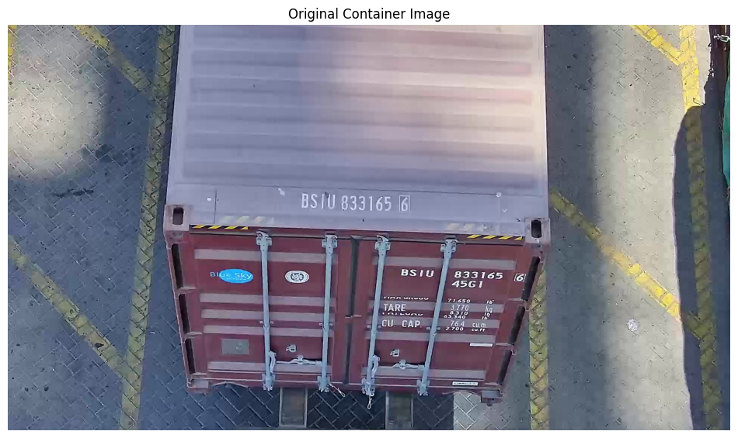

**EasyOCR**

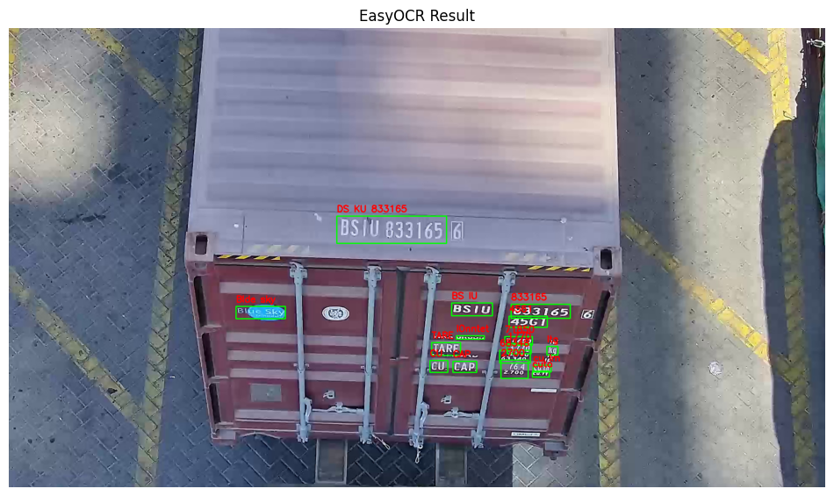

**DL pipline(Contour+tesseract)**

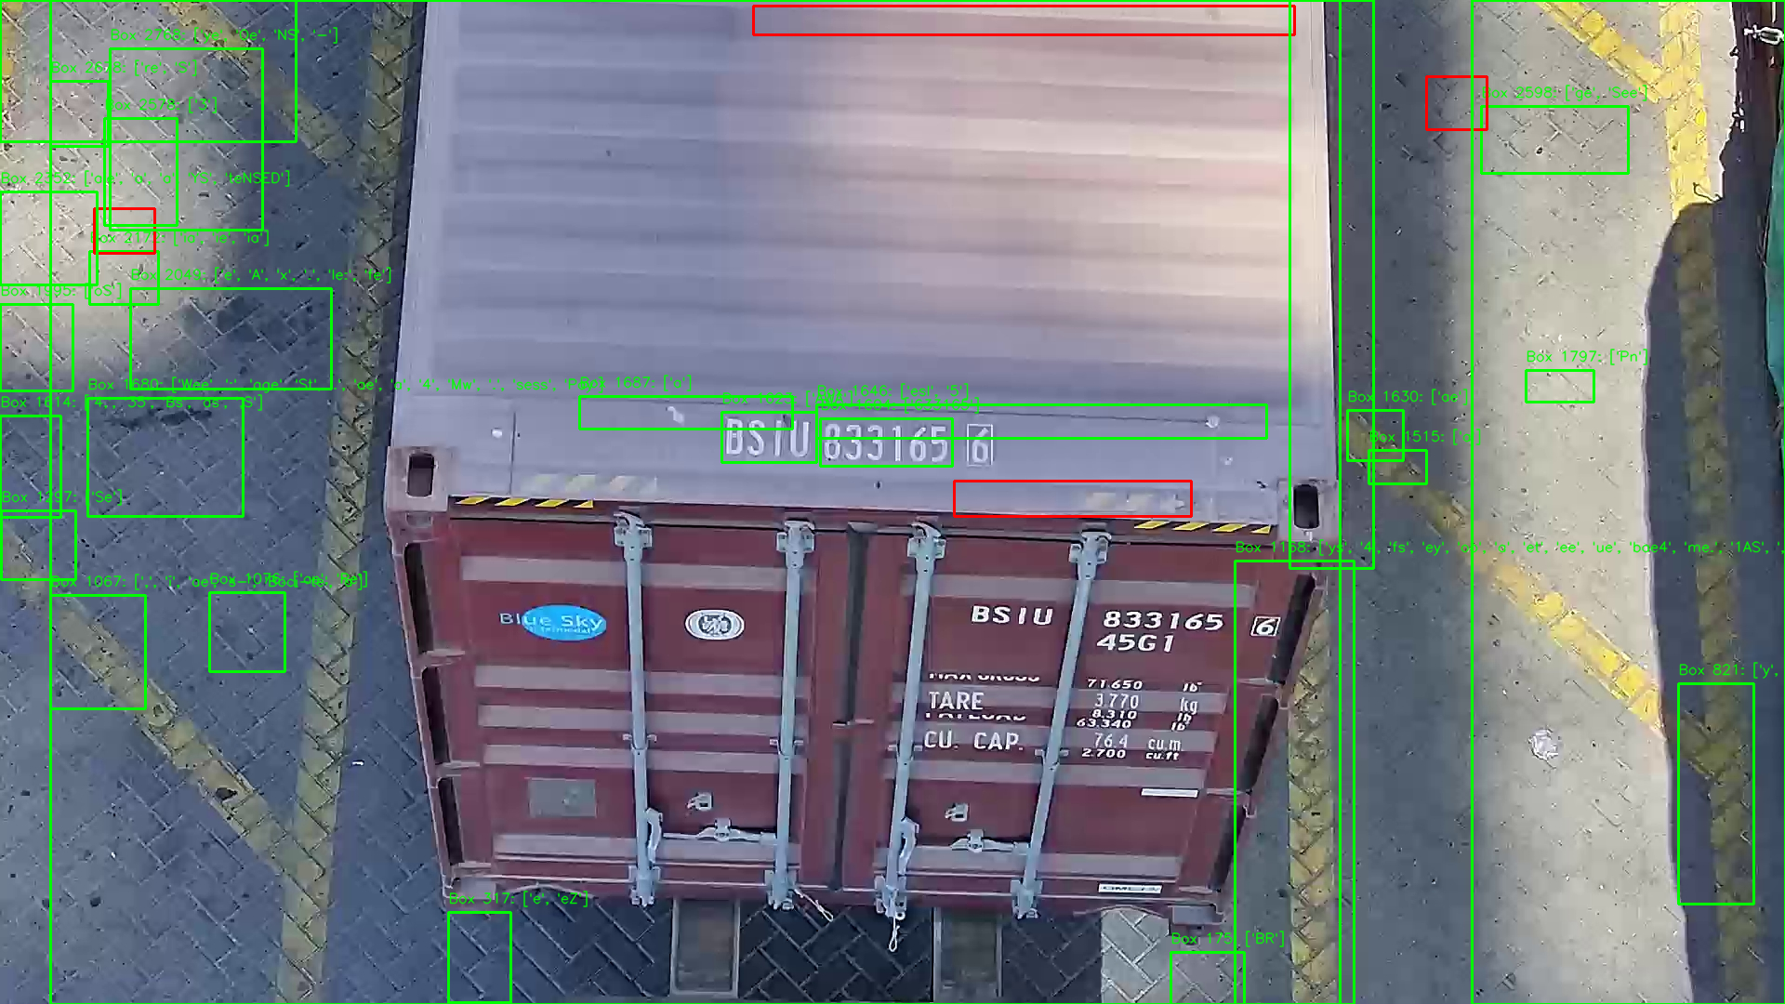

**KerasOCR**

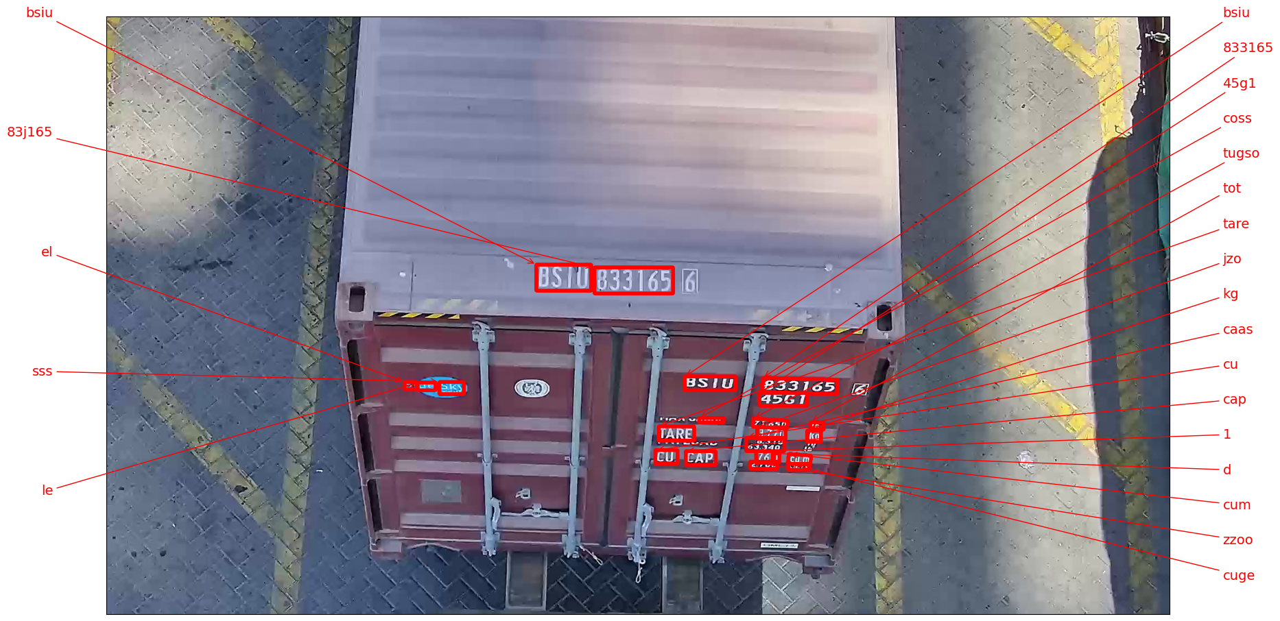

**PaddleOCR**

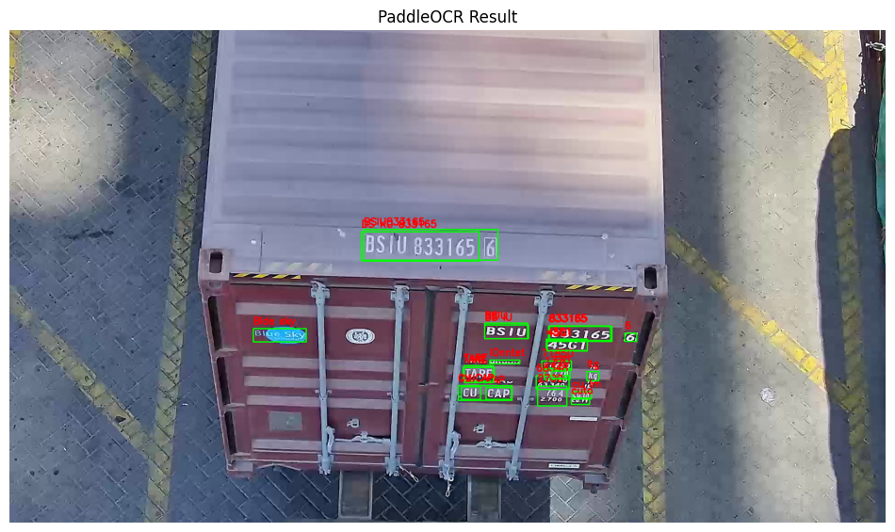

**Conclusion**

Test-Time Augmentation (TTA) combined with EasyOCR yielded the most reliable results for extracting printed information from a noisy container image. Other methods either lacked accuracy or could not be executed due to environment or dependency limitations.